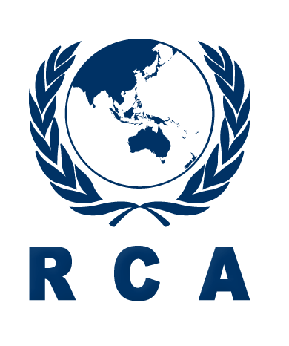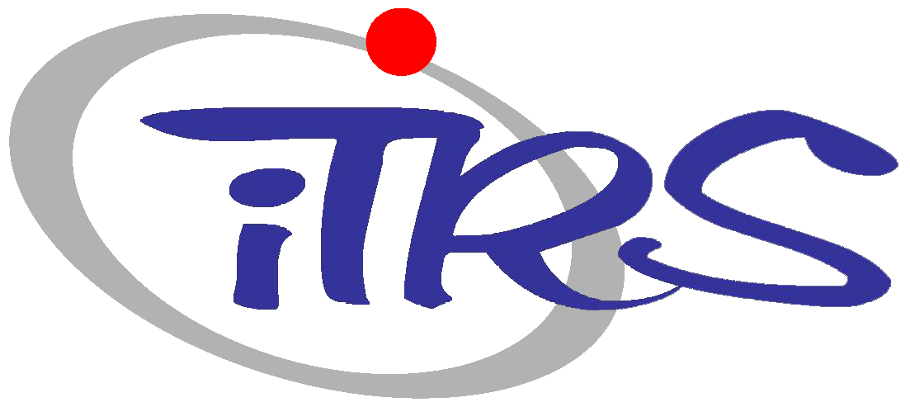
2018 RCA/iTRS Radiation Safety Training Course

PROSPECTUS

Title : | 2018 RCA/ iTRS Radiation Safety Training Course
Place : | Hanyang University, Seoul, Republic of Korea
Date : | 20 August to 24 August 2018
Deadline for  Nominations : | 13 July 2018
Organizers : | RCA in cooperation with Innovative Technology Center for Radiation Safety (iTRS) of Hanyang University
Course Organizers : | Mr JinKyu LIM  Head, Administration of RCA Regional Office  Tel: +82 42 868 4905  E-mail: jklim@rcaro.org  Dr. Chang-ho SHIN  Innovative Technology Center for Radiation Safety  Hanyang University  Tel: +82 2 2220 4678  E-mail: gemini@hanyang.ac.kr
Language: | The language of instruction will be English
Participation: | The training course is open to 12-14 participants from RCA Government Parties.  Each Government Party will be able to nominate up to one or two candidates.
Target Countries: | Bangladesh, Cambodia, China, Fiji, India, Indonesia, Laos, Malaysia, Mongolia, Myanmar, Nepal, Pakistan, Philippines, Palau, Sri Lanka, Thailand, Vietnam
Purpose of the  Course : | The purpose of the training course is to improve technical and practical knowledge on radiation safety.
Scope : | The training course will include lectures by recognized experts from related institutes in Korea in the areas of radiation safety covering radiation safety management, medical radiation safety and control, industrial radiation safety and control, transportation of radioactive materials and radiation safety culture.
Participants’ qualifications and experience : | Participants should be technical or managerial professionals directly involved in the field of radiation technology in government authorities, R&D institutes, and regulatory bodies with maximum of 5 years relevant experience in the field. Bachelor’s degree or equivalent experience is required.  Participants should have sufficient proficiency in English to follow lectures without difficulty.
Application Procedure : | Completed application forms should be endorsed and approved by the National RCA Representatives and be received at the below address no later than 13 July 2018.  Ms Jinhwa KIM  Project Officer  RCA Regional Office  111, Daedeok-Daero 989 Beon-Gil, Yuseong-gu, Daejeon, 34057  Republic of Korea  Tel: +82 42 868 8584  Fax: 82 42 864 1626  E-mail: evolution@rcaro.org  Nominations received after this date or applications which have not been endorsed by the National RCA Representatives cannot be considered.
Administrative and Financial  Arrangements: | During the training course, RCA Regional Office(RCARO) will provide the participants with a stipend sufficient to cover the cost of their accommodation, food and minor incidental expenses. RCARO will also provide the participants with a round-trip air ticket, economy class, from their home countries to Incheon, Korea and return.  Participants will be provided with standard travel insurance. However, the organizers of the training course do not accept liability for the payment of any cost or compensation that may arise from damage to or loss of personal property, or from illness, injury, disability or death of a participant while he/she is travelling to and from or attending the training course and it is clearly understood that each Government, in nominating participants, undertakes responsibility for such coverage. Governments would be well advised to take out insurance against these risks.

2018 RCA/iTRS Radiation Safety Training Course

20 August to 24 August 2018, Seoul, Korea
Date | Time | Lecture | Lecturer
Aug. 20 | 09:00-09:30 | Course Introduction
 | 09:30-11:00 | Philosophy of Radiation Safety
 | 11:00-11:30 | Break
 | 11:30-13:00 | System of Radiological Protection
 | 13:00-14:30 | Lunch
 | 14:30-16:00 | Detectors for Radiation Safety Management
 | 16:00-18:00 | Tour to Seoul Radiation Monitoring Post and Radiation Labs at Hanyang University
Aug. 21 | 09:00-10:30 | Medical Radiation Safety and Control
 | 10:30-11:00 | Break
 | 11:00-12:30 | Industrial Radiation Safety and Control
 | 12:30-14:00 | Lunch
 | 14:00-15:30 | RI/RG Radwaste Management
 | 15:30-16:00 | Break
 | 16:00-17:30 | Health Effects of Radiation
 | 18:00-20:00 | Course Dinner
Aug. 22 | 09:00-10:30 | Radiation Safety and Shielding Analysis
 | 10:30-11:00 | Break
 | 11:00-12:30 | Activation Analysis for Accelerator Facilities
 | 12:30-14:00 | Lunch
 | 14:00-15:30 | Transportation of Radioactive Materials
 | 15:30-17:30 | Technical Tour to Korea Institute of Radiological and Medical Science (KIRAMS)
Aug. 23 | 09:00-10:30 | Radiation Emergency Preparedness
 | 10:30-11:00 | Break
 | 11:00-12:30 | Protection of NORM
 | 12:30-14:00 | Lunch
 | 14:00-18:30 | Radiation Safety Culture
Aug. 24 | 09:00-10:30 | Radiation Safety Control and Regulations
 | 10:30-11:00 | Break
 | 11:00-12:30 | Radiation Risk Communication and Public Acceptance
 | 12:30-13:00 | Course Evaluation / Awarding Certificates / Closing
 | 13:00-14:00 | Lunch

