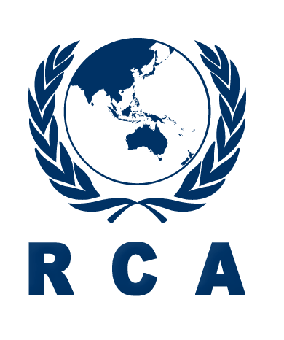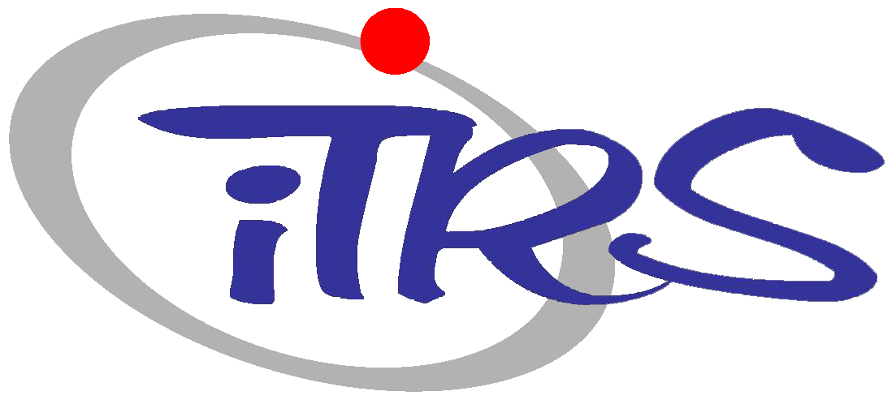
2020 RCA/iTRS-HYU Radiation Safety Training Course (e-Learning)

PROSPECTUS

Title: | 2020 RCA/ iTRS-HYU Radiation Safety Training Course(e-Learning)
Date: | 2-13 November 2020
Learning Platform: | Asian Network for Education in Nuclear Technology (ANENT) Regional Learning Management System (RLMS) (http://lms.anent.online)
Organizers: | RCA in cooperation with Innovative Technology Center for Radiation Safety (iTRS) of Hanyang University
Course Organizers: | Mr JinKyu LIM  Head, Administration of RCA Regional Office  Tel: +82 42 868 4905  E-mail: jklim@rcaro.org  Dr. Chang-ho SHIN  Innovative Technology Center for Radiation Safety  Hanyang University  Tel: +82 2 2220 4678  E-mail: gemini@hanyang.ac.kr
Language: | The language of instruction will be English
Participation: | The training course is open to 15-20 participants from RCA Government Parties.  Each Government Party will be able to nominate up to one or two candidates.
Target Countries: | Bangladesh, Cambodia, China, Fiji, India, Indonesia, Laos, Malaysia, Mongolia, Myanmar, Nepal, Pakistan, Philippines, Palau, Sri Lanka, Thailand, Vietnam
Purpose of the  Course: | The purpose of the training course is to improve technical and practical knowledge on radiation safety.
Scope: | The training course will include lectures by recognized experts from related institutes in Korea in the areas of radiation safety covering radiation safety management, medical radiation safety and control, industrial radiation safety and control, transportation of radioactive materials and radiation safety culture.
Benefits for Outstanding Participants | Participants(within 5 people) who have completed this course with excellent grades will be given the opportunity to participate in a Scientist visit(within 5days) in Korea
Guidelines for e-Learning: | All participants will be given an ID and a password to log in to the e-Learning platform (http://lms.anent.online) before starting this e-Learning course. Learning objectives, lectures, and assignments in each subject will be provided in consecutive order when the participants “click” the subject in the e-Learning website on the platform.
Application Procedure: | Completed application forms should be endorsed and approved by the National RCA Representatives and be received at the below address no later than 9 October 2020.  RCARO  Tel: +82 42 868 2777  Fax: 82 42 864 1626  E-mail: rcaapply@rcaro.org  Nominations received after this date or applications which have not been endorsed by the National RCA Representatives cannot be considered.
Administrative Arrangements: | National RCA Representatives will be informed of the result of selection procedures by the RCARO and the selected participants will be given full details of the procedures to be followed with information regarding the administrative matters.

Appendix 1. Curriculum for 2020 RCA/ iTRS-HYU Radiation Safety Training Course(e-Learning)

1 | Opening Ceremony and Welcoming Remarks (RCA/iTRS)
2 | Introduction
  - Participants Introduction

  - Course Introduction

  - Introduction of RCARO
3 | Radiation Safety Training
 | 2.1 | Radiation Dose
 | 2.2 | Health Effects of Radiation
 | 2.3 | System of Radiological Protection
 | 2.4 | Medical Radiation Safety and Control
 | 2.5 | Radiation Detectors
 | 2.6 Neutron Detection
 | 2.7 Radiation Safety and Shielding Analysis
 | 2.8 RI/RG Radwaste Management
 | 2.9 External Dose Assessment
 | 2.10 Radiation Emergency Preparedness
 | 2.11 NORM Radiation Safety and Control
 | 2.12 Radiation Safety Culture
 | 2.13 Internal Dose Assessment
 | 2.14 Radiation Risk Communication and Public Acceptance
 | 2.15 Vedio Tour for Korean Culture Experience
4 | Course Evaluation /Closing
※ The above curriculum is subject to change depending on the circumstances.

